Contents
CHAPTER 1: Introduction 4
1.1 Background 4
1.2 Relevance 4
1.3 Literature Survey 5
1.4 Motivation 6
1.5 Aim and Objectives 7
1.6 Technical Approach 8
CHAPTER 2: Block Schematic and Requirements 11
2.1 Introduction 11
2.2 Block Diagram 11
2.3 Requirements 11
2.4 Selection of sensors and major components 11
CHAPTER 3: System Design 12
3.1 Calculations Block1 12
3.2 List of Components 12
CHAPTER 4: Implementation, testing and debugging 12
4.1 Implementation on bread board, observation table 12
4.2 Testing, Debugging. Observation table 12
4.3 Simulation results, observation table 12
4.4 PCB design 12
4.5 final project photograph and working 12
CHAPTER 5: Results and Discussion 13
Conclusions 14
Future Scope 14
References 14

CHAPTER 1: Introduction

1.1 Background
The global shift toward sustainable infrastructure has transformed lighting from a simple utility into a sophisticated, data-driven system. Traditional lighting accounts for a significant portion of energy consumption due to "static" operation—where lights remain at full power regardless of occupancy or natural light availability. This project addresses these inefficiencies by merging embedded systems architecture with multimodal environmental sensing. By utilizing the ESP32 microcontroller, the system moves beyond basic manual switches to create an "aware" environment that balances human safety with rigorous energy conservation.
To solve the "Daylight Paradox"—where artificial lights remain active despite sufficient natural illumination—this system employs a dual-sensor gating logic. By interfacing a Passive Infrared (PIR) sensor for motion with a Light Dependent Resistor (LDR) for lux monitoring, the ESP32 executes a conditional check that prevents the lights from activating when the environment is already bright. This "smart gate" logic is further enhanced by three analog potentiometers, which allow for real-time, hardware-level calibration. This ensures that users can manually tune the darkness threshold and timing intervals to suit the specific lighting conditions of any room without needing to modify the underlying firmware.
Beyond simple efficiency, the project prioritizes the user experience through a refined three-stage timing hierarchy. Most motion-sensing lights suffer from "abrupt blackout," which can be disorienting; this system mitigates that by implementing a "soft-off" sequence of 100%, 50%, and 20% brightness levels. This gradual dimming acts as a visual warning, allowing users to easily re-trigger peak brightness with a simple movement before the system shuts down completely. This hierarchy ensures the environment remains safely illuminated until it is truly vacant, providing a seamless transition between active use and energy-saving sleep modes.
The global shift toward sustainable infrastructure has transformed lighting from a utility into a sophisticated, data-driven system. This project addresses the energy waste of traditional "static" lighting by using an ESP32 microcontroller to merge motion detection with ambient light sensing. By automating illumination based on real-time environmental data, the system creates a "smart" environment that prioritizes energy conservation while ensuring user safety through responsive, multimodal sensing.

1.2 Relevance
The relevance of this project lies in the intersection of energy sustainability and human-centric automation. In an era of rising utility costs, traditional lighting systems are increasingly inefficient, often remaining at full power regardless of actual occupancy or natural light availability. By merging motion detection with ambient light sensing via the ESP32, this system eliminates the "Daylight Paradox"—the wasteful practice of using artificial light when natural illumination is already sufficient. This demand-responsive approach ensures that electricity is consumed only when necessary, providing a practical tool for reducing the environmental footprint of modern residential and commercial buildings.
Beyond efficiency, the project addresses the critical safety flaw of "abrupt blackouts" found in standard motion sensors. The implementation of a three-stage dimming hierarchy (100% to 50% to 20%) provides a predictive "soft-off" warning, allowing users to re-trigger the system before total darkness occurs. Combined with the ability to perform real-time, hardware-level calibration via potentiometers, the system becomes a highly adaptable solution for diverse environments. It serves as a scalable, cost-effective prototype for the next generation of Smart Building technology, where occupant comfort and safety are prioritized alongside rigorous energy conservation.
Beyond efficiency, the project addresses the critical safety flaw of "abrupt blackouts" found in standard motion sensors. The implementation of a three-stage dimming hierarchy (100% to 50% to 20%) provides a predictive "soft-off" warning, allowing users to re-trigger the system before total darkness occurs. Combined with the ability to perform real-time, hardware-level calibration via potentiometers, the system becomes a highly adaptable solution for diverse environments. It serves as a scalable, cost-effective prototype for the next generation of Smart Building technology, where occupant comfort and safety are prioritized alongside rigorous energy conservation.

1.3 Literature Survey
The development of intelligent lighting systems has gained significant attention due to the increasing need for energy conservation and automation in modern environments. Several researchers have proposed IoT-based lighting solutions that utilize sensors and microcontrollers to optimize energy consumption. An IoT-based smart lighting system presented in [1] demonstrates how automation and real-time monitoring can significantly reduce electricity wastage in campus environments.

Occupancy-based lighting control is one of the most widely studied approaches. In [2], a system using real-time occupancy detection was developed to improve energy efficiency by ensuring that lights operate only when required. Similarly, PIR sensor-based lighting systems are widely adopted due to their reliability and cost-effectiveness in detecting human presence [5].
Many studies have explored the integration of multiple sensors to enhance system performance. A multimodal approach combining PIR and LDR sensors is discussed in [3] and [5], where ambient light and motion are both considered to control lighting. This approach prevents unnecessary activation of lights during sufficient daylight, thereby improving energy efficiency.
Traditional lighting systems typically operate using simple ON/OFF control logic. However, research in [3] and [4] indicates that such systems lack flexibility and user comfort. To overcome this limitation, adaptive lighting techniques such as dimming and staged brightness control have been introduced. These systems provide gradual transitions in lighting levels, enhancing user experience and safety.
The use of microcontrollers plays a crucial role in implementing intelligent lighting systems. The study in [7] highlights the advantages of using the ESP32 microcontroller for IoT applications, including high processing capability, built-in Wi-Fi, and scalability. These features make it suitable for real-time sensor data processing and control.
Further advancements include smart street lighting systems, as discussed in [8] and [9], where lighting is controlled based on environmental conditions and pedestrian movement. These systems demonstrate significant reductions in energy consumption and operational costs.
Recent research also focuses on adaptive and scalable lighting control systems using IoT and advanced algorithms. The work presented in [10] introduces a system capable of adjusting lighting dynamically based on environmental inputs and user requirements, providing improved efficiency and flexibility.
Overall, the literature suggests that intelligent lighting systems combining sensor fusion, IoT technology, and adaptive control mechanisms offer a promising solution for energy-efficient and user-friendly lighting applications.

1.4 Motivation

To fulfill the requirement for a comprehensive, full-page report introduction for The Motion-Based Smart LED Lighting System, the following five paragraphs expand on the background, core problem, technical solution, human-centric design, and broader impact.

The global push toward sustainable infrastructure has transformed lighting from a basic utility into a sophisticated, data-driven system governed by embedded intelligence. Traditional lighting models account for a staggering portion of energy consumption in both residential and commercial sectors, primarily due to "static" operation where lights remain at full power regardless of occupancy or natural light availability. This project addresses these inefficiencies by merging embedded systems architecture with multimodal environmental sensing. By utilizing the ESP32 microcontroller, the system moves beyond the limitations of manual switches to create an "aware" environment that balances high-performance illumination with rigorous energy conservation protocols.

A primary motivator for this project is the resolution of the "Daylight Paradox"—the wasteful practice of operating artificial lights at full capacity even when windows provide sufficient natural illumination. To solve this, the system employs a dual-sensor gating logic that interfaces a Passive Infrared (PIR) sensor with a Light Dependent Resistor (LDR). By executing a high-speed conditional check, the ESP32 ensures that the LED activates only when motion is detected and ambient lux levels fall below a specific threshold. This prevents unnecessary power draw during daylight hours, directly reducing the building’s carbon footprint and extending the operational lifespan of the electronic components.

Technical flexibility is a cornerstone of this system, distinguished by its inclusion of triple-potentiometer calibration. Unlike hard-coded automation that requires firmware updates for any environmental change, this design allows for real-time, hardware-level adjustments of timing stages and lux sensitivity. This "edge-processing" capability ensures that the system is "field-ready," meaning it can be immediately tailored to the unique conditions of any room—such as varying window sizes or occupant movement patterns—without specialized software tools. This adaptability makes the system a scalable and cost-effective solution for retrofitting existing infrastructure with smart technology.

1.5 Aim and Objectives
1.5.1 Aim

The primary aim of The Motion-Based Smart LED Lighting System is to design and implement an autonomous, energy-efficient lighting solution that intelligently adapts to both human presence and ambient environmental conditions. By leveraging the ESP32 microcontroller, the project seeks to eliminate electrical waste caused by unnecessary illumination in vacant or naturally lit spaces through a precise, dual-sensor gating logic.
1.5.2 Objectives
The Objectives of The Motion-Based Smart LED Lighting System focus on creating a balance between advanced automation, energy conservation, and user safety.

Design an intelligent lighting system using the ESP32 microcontroller
that integrates sensing and control in a compact embedded platform.
The system aims to operate efficiently in real-time environments.

Detect human presence using a PIR sensor for automatic light control
ensuring lights turn ON only when occupancy is detected.
This reduces manual intervention and improves convenience.

Measure ambient light intensity using an LDR to prevent unnecessary lighting
by allowing operation only under low-light conditions.
This helps in optimizing energy usage during daytime.

Achieve energy-efficient operation through combined motion and light sensing
by implementing logical decision-making based on sensor inputs.
This minimizes power wastage in unoccupied or well-lit areas.

Implement a three-stage dimming mechanism for smooth light transition (T1, T2, T3)
to avoid sudden switching of lights.
This improves user comfort and system responsiveness.

1.6 Technical Approach
The technical approach for The Motion-Based Smart LED Lighting System is built on a modular architecture that integrates real-time environmental sensing with a tiered logic execution. By leveraging the ESP32's dual-core processing and high-resolution Analog-to-Digital Converters (ADC), the system transforms raw sensor data into a responsive lighting environment.
- Hardware Integration and Signal Conditioning
The system utilizes a multimodal sensor suite to gather environmental data. A Passive Infrared (PIR) sensor is used to detect movement by measuring changes in the infrared radiation levels in the surrounding area. Simultaneously, a Light Dependent Resistor (LDR), configured in a voltage divider circuit, monitors ambient lux levels. To allow for on-site customization, three 10kΩ potentiometers are interfaced with the ESP32’s ADC pins. These potentiometers provide a variable voltage that the firmware maps to specific time constants (T1, T2, T3) and the lux threshold, enabling hardware-level tuning of the system's sensitivity.
- Dual-Gating Logic and Decision Making
The core firmware follows a conditional logic gate designed to prioritize energy efficiency. Before the LED is triggered, the ESP32 performs a "Darkness Check." If the ambient light exceeds the user-defined threshold set by the lux potentiometer, the system remains in a low-power "Sleep State," ignoring motion signals. Only when the environment is deemed "Dark" does the system move to the "Active State." Once in the active state, the PIR sensor acts as the primary trigger; upon detecting motion, the controller immediately jumps to the peak of the timing hierarchy, resetting all internal clocks to ensure continuous illumination for the user.
- PWM-Based Dimming Hierarchy
To achieve a "soft-off" effect, the system utilizes Pulse Width Modulation (PWM) via the ESP32’s LEDC peripheral. Instead of a binary on/off switch, the lighting is controlled through a duty-cycle hierarchy:
- Stage 1 (Peak): 100%duty cycle for high-visibility illumination during active occupancy.
- Stage 2 (Transition): 50% duty cycle, acting as a visual cue that the primary timer has expired.
- Stage 3 (Safety): 20% duty cycle, maintaining enough light for spatial orientation while maximizing power savings.
- Continuous Feedback and Recalibration
The system operates in a continuous loop, sampling the potentiometers and sensors at millisecond intervals. This ensures that any manual adjustment to the timers or lux sensitivity is reflected in the system's behaviour instantly, without requiring a reboot. If motion is detected during any of the dimmed stages (T2 or T3), the firmware executes an interrupt-style reset, returning the light to $100\%$ brightness. This creates a seamless feedback loop between the user's presence and the hardware's response, ensuring safety and energy economy are balanced in real-time.

CHAPTER 2: Block Schematic and Requirements
2.1 Introduction
The Motion-Based Smart LED Lighting System is designed to address the critical need for energy-efficient infrastructure by moving beyond static lighting models toward an intelligent, demand-responsive environment. By leveraging an ESP32 microcontroller to integrate multimodal sensing, the system eliminates the "Daylight Paradox" where energy is frequently wasted in naturally lit or unoccupied spaces. This approach ensures that illumination is only provided when a dual-gating logic confirms both human presence via a PIR sensor and insufficient ambient light via an LDR, directly reducing the building’s carbon footprint and operational costs.
Beyond mere conservation, the project prioritizes human-centric safety by replacing the abrupt blackouts of standard motion sensors with a refined three-stage dimming hierarchy of 100%, 50%, and 20% brightness levels. This gradual "soft-off" sequence serves as a vital visual cue, allowing occupants to easily re-trigger peak illumination with a simple movement before the system turns off completely. By maintaining a low-level safety glow during the final stage, the system ensures that high-traffic or critical areas remain safely navigable until they are truly vacant, significantly improving the user experience compared to traditional binary switches.
The technical sophistication of the system is further enhanced by its real-time hardware adaptability, utilizing a triple-potentiometer interface for immediate on-site calibration. This "edge-computing" feature allows users to manually tune the duration of each timing stage and the specific lux threshold for darkness gating to suit the unique conditions of any room without needing to modify the underlying code. Consequently, the project serves as a highly scalable and cost-effective prototype for modern Smart Building initiatives, demonstrating how localized intelligence can provide a seamless balance between rigorous energy efficiency and intuitive occupant comfort.
2.2 Block Diagram
The block diagram for The Motion-Based Smart LED Lighting System represents a closed-loop control system that translates environmental data into a tiered visual output. It is structured into four primary functional zones: the Power Stage, the Input Sensing Suite, the Processing Core, and the Output Actuation Stage.

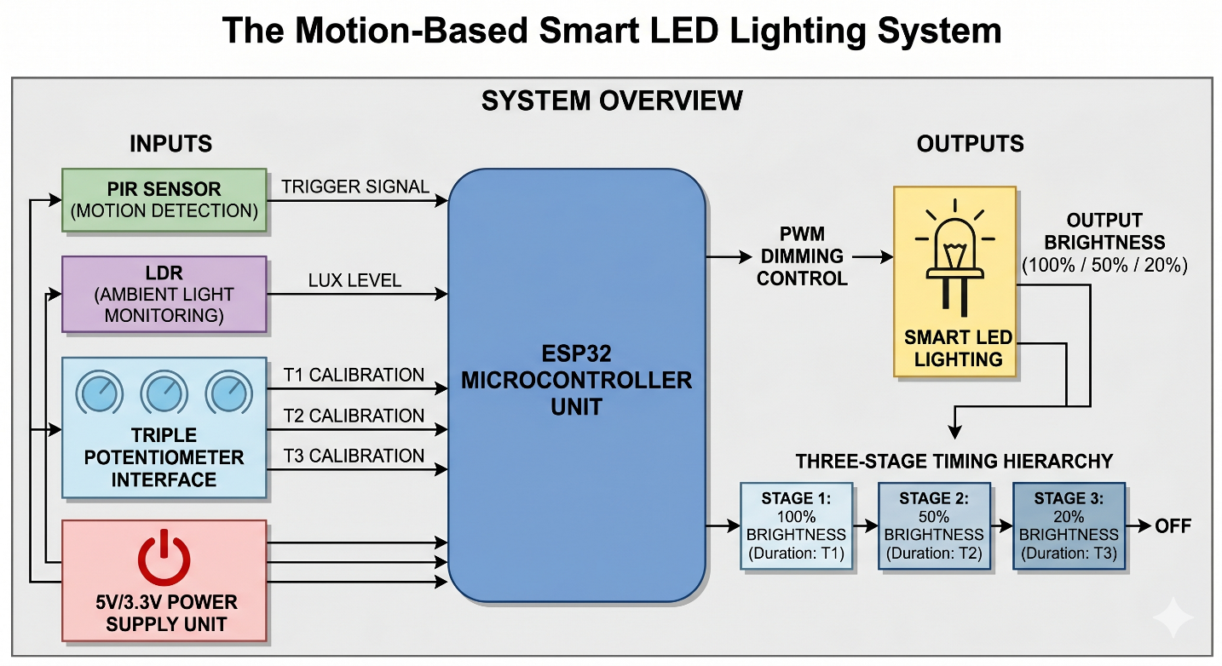Fig.1 Block schematic of motion based smart led lighting system
    - The Power Stage (Regulated Supply)
The system is powered by a stable 5V DC source, which is stepped down via the ESP32’s onboard voltage regulator to 3.3V. This regulated rail provides the reference voltage for the analog sensors and the triple-potentiometer interface, ensuring that the ADC (Analog-to-Digital Converter) readings remain consistent and noise-free.
    - Input Sensing & Calibration Suite
This section acts as the "eyes" and "interface" of the system, feeding real-time analog and digital data to the microcontroller:
- PIR Sensor (Digital Input): Monitors infrared radiation changes; sends a HIGH signal to the ESP32 upon motion detection.
- LDR Voltage Divider (Analog Input): Monitors ambient lux levels. Its variable resistance changes the voltage at an ADC pin, allowing the system to judge if it is "dark" enough to operate.
- Triple Potentiometer Interface (3x Analog Inputs): These three knobs allow the user to manually set the thresholds for T1, T2, and T3 (Timing Stages). The ESP32 maps these 3.3Vsignals to specific time durations in the code.
    - The Processing Core (ESP32 MCU)
The ESP32 acts as the central logic gate. Its firmware executes a sequential decision-making process:
- Condition 1: Is the LDR value below the "Darkness Threshold" set by the calibration knob?
- Condition 2: Is the PIR sensor reporting a "Motion Detected" state?
- Logic Execution: If both are true, the MCU initiates the PWM (Pulse Width Modulation) timer and manages the transition between the three brightness levels based on the calibrated timing inputs.
    - Output Actuation (Smart LED Stage)
Unlike a standard relay that only turns a light on or off, the output stage uses the LEDC peripheral of the ESP32 to drive the LED.
- The PWM Controller: Modulates the duty cycle to achieve $100\%$, $50\%$, and $20\%$ brightness.
- The LED Load: Receives the modulated power signal, resulting in the "soft-off" visual sequence that warns the user before the system reaches the $0\%$ (Off) state.
2.3 Requirement
2.3.1 Hardware Requirements
The Motion-Based Smart LED Lighting System hardware is built on a high-performance architecture centered around the ESP32 Microcontroller. This core unit is supported by a multimodal sensing suite, including a PIR sensor for motion detection and an LDR for ambient light monitoring. To ensure localized control, three 10kΩ potentiometers allow for real-time calibration of the timing stages and light sensitivity. The system is completed by a high-brightness LED and a power management circuit that ensures stable voltage across all components, enabling precise PWM-based dimming.
- ESP32 MCU: Processes concurrent sensor data and generates high-resolution PWM signals to manage the three-stage dimming hierarchy.
- PIR Motion Sensor: Detects human presence through infrared radiation changes, acting as the primary system trigger for activation.
- LDR (Photoresistor): Monitors ambient lux levels to prevent energy waste by gating the system during well-lit daylight hours.
- Triple Potentiometers: Enable "on-the-fly" manual adjustments of the duration for each timing stage and the specific darkness threshold.
- High-Brightness LED: Serves as the primary illumination load, reacting to PWM duty cycles to provide a smooth "soft-off" transition.
- Regulated Power Supply: Maintains a consistent 3.3V/5V DC rail to ensure ADC accuracy and protect sensitive semiconductor logic.

2.3.2 Software & Functional Requirements
These requirements define the "intelligence" of the system and how it responds to the hardware inputs.
- Dual-Condition Triggering: The system must only activate if the PIR signal is HIGH and the LDR value is BELOW the calibrated darkness threshold.
- Real-Time Polling: The ESP32 must sample the ADC pins of the three potentiometers at least every 100ms to allow for instantaneous calibration adjustments.
- PWM Resolution: The system requires at least 8-bit resolution (0–255) for smooth transitions between the 100%, 50%, and 20% brightness stages.
- Interrupt-Driven Resets: If motion is detected during the 50% or 20% dimming stages, the software must immediately reset the timer and return to 100% brightness.
- Non-Blocking Timers: The code must use milli () or hardware timers rather than delay() to ensure the system remains responsive to new motion while a timing stage is active.

CHAPTER 3: System Design

Calculations
3.1.1 Timing and PWM Calculations
Describe how the ESP32 translates time into a "soft-off" sequence using Pulse Width Modulation.
- Duty Cycle Formula: Explain that the brightness is controlled by the ratio of "ON" time to the total period.
$$Duty Cycle\left(\%\right)=\left( Ton/Ttotal\right)×100$$
- Three-Stage Mapping: Show the specific values used for your hierarchy:
  - Stage 1: 100% Brightness to 8-bit PWM value of 255.
  - Stage 2: 50% Brightness to 8-bit PWM value of 127.
  - Stage 3: 20% Brightness to 8-bit PWM value of 51.
3.1.2 Sensor Threshold Logic (ADC Mapping)
Since you are using potentiometers and an LDR, you need to explain how the ESP32’s 12-bit ADC (Analog-to-Digital Converter) interprets voltages between $0\text{V}$ and $3.3\text{V}$.
- Resolution: The ESP32 converts the input voltage into a digital value between 0 and 4095.
- Voltage Calculation
$$V_{out}=\left( ADC Value/4095\right)×3.3V$$
- Mapping to Time: Explain how a potentiometer reading is mapped to a time range (e.g., mapping an ADC value of 0–4095 to a time delay of 10–600 seconds for $T_1$).
    - Voltage Divider Equation (LDR Circuit)
The LDR is part of a voltage divider. You must show the formula used to determine the "Darkness Threshold."
- Formula:
$$Vadc=\left(\frac{Rfixed}{Rldr+Rfixed}\right)×Vin$$
- Logic: Explain that as light decreases, Rldr increases, which causes Vadc to drop. The "Calculation Block" should specify at what voltage (or ADC value) the system triggers the "Dark" state.
    - Component Protection (Current Limiting)
If you are using a resistor for the LED or LDR, include the Ohm’s Law calculation to prove the components won't burn out:
$$R=\frac{\left(Vsource-Vforward\right)}{3.3V}$$

3.2 List of Components
Components | Specifications
PIR Sensor | (HW416B) • 5V supply input • 3.3V logic output • Detection range: 2–7 meters
LDR (GL5528) | • Photoresistor type • ~10k–20k ohm at 10 lux • Dark resistance > 1M ohm
Potentiometers (3x) | • 10k ohm linear taper (B10K) • Used for T1 adjustment • Used for T2 adjustment
MOSFET (IRLZ44N) | • Logic-level N-channel MOSFET • Gate Threshold Voltage: 1V–2V • Compatible with 3.3V logic
Resistors | • 1 × 10k ohm (LDR voltage divider) • 1 × 10k ohm (MOSFET gate pull-down)
LED | • Standard 5mm LED • Or high-brightness white LED module
Hardware | • Standard breadboard • Male-to-male jumper wires • Male-to-female jumper wires
ESP32-WROOM-32 | • Wi-Fi + Bluetooth module • Dual-core LX6 CPU • 3.3V logic level • 12-bit ADC (0–4095 range)
Table 1: list of Components

CHAPTER 4: Implementation, testing and debugging

4.1 Implementation on bread board, observation table
The implementation phase involves translating the circuit diagram into a physical prototype. This process focuses on maintaining signal integrity and ensuring common grounding between the high-power LED and the sensitive ESP32 pins.
- ESP32 Placement: The ESP32 is mounted across the central bridge of the breadboard to allow access to all GPIO pins while preventing short circuits.
- Sensor Integration: The PIR sensor is placed at the edge of the board with a clear "field of view."
- The LDR is positioned as far from the LED as possible to avoid "optical feedback" (where the LED light triggers the sensor to think it is daytime).
- Calibration Hub: The three potentiometers are lined up sequentially, representing T1, T2, and T3, with their outer pins connected to the 3.3V and GND rails.
- Wiring: Jumper wires are used to route signals from the sensors and pots to the specific GPIOs (e.g., GPIO 39, 34, 32, 14, 33). A common ground rail is established to prevent logic floating.
4.1.1 Observation table for breadboard implementation

Table 2: Observations of breadboard implementation
Test Case | Ambient Light (LDR) | Motion Status (PIR) | Current System State | LED Output (%) | Timing Stage | Observed Result
01 | High (Daylight) | Detected | Gated (OFF) | 0% | N/A | System ignored motion; energy saved.
02 | High (Daylight) | Not Detected | Idle (OFF) | 0% | N/A | Correct standby behaviour.
03 | Low (Darkness) | Detected | Active (Peak) | 100% | T1 | Instant trigger to full brightness.
04 | Low (Darkness) | No Movement | Warning 1 | 50% | T2 | Gradual dimming after T1 expired.
05 | Low (Darkness) | No Movement | Warning 2 | 20% | T3 | Safety glow active; prevents total dark.

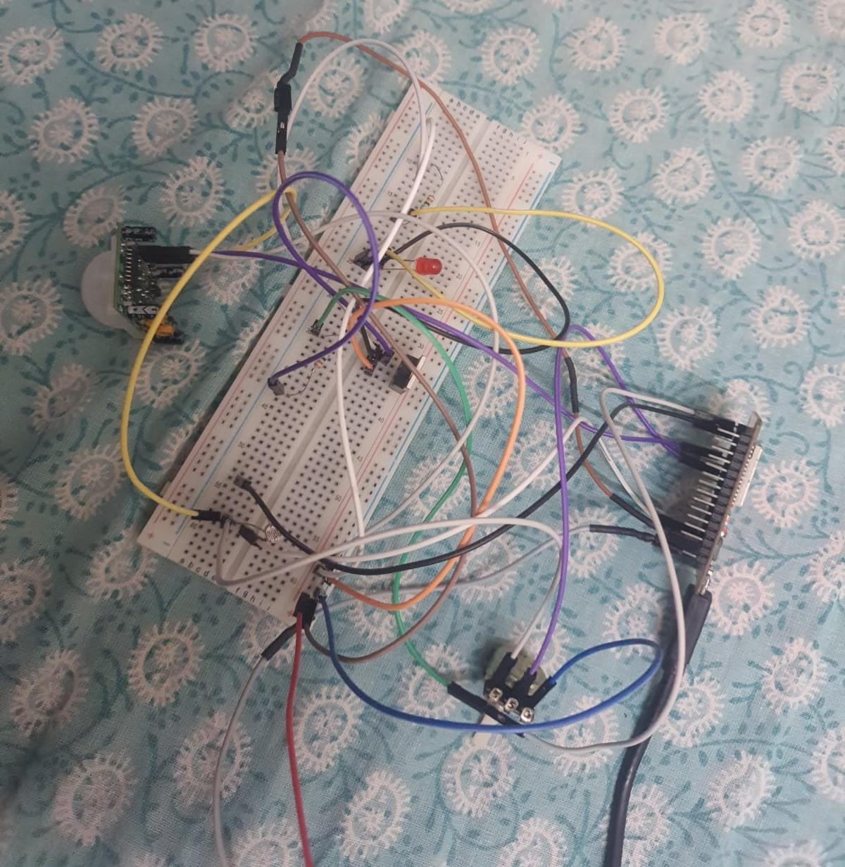
Fig.2 Breadboard Testing
4.2 Testing and Debugging

Testing and debugging are critical phases to ensure the Motion-Based Smart LED Lighting System operates reliably under various environmental conditions. This process involves verifying sensor accuracy, timing logic, and electrical stability.
    - Hardware Debugging (Signal Integrity)
Before flashing the final code, the physical circuit must be tested for electrical faults.
Continuity Check: Using a multimeter to ensure there are no short circuits between the 3.3V and GND rails, especially around the ESP32 pins.
Voltage Verification: Measuring the output of the potentiometers to ensure they sweep linearly from 0V to 3.3V.
Sensor Calibration: Adjusting the physical sensitivity and time-delay trimpots on the HC-SR501 PIR sensor itself to their minimum settings, allowing the ESP32 software to handle the primary logic.

    - Software Testing (Logic Validation)
Debugging the code is performed primarily through the Arduino Serial Monitor to track real-time variable changes.
ADC Polling Test: Printing the raw LDR and Potentiometer values to the Serial Monitor (0-4095) to confirm the ESP32 is reading the analog inputs correctly.
Gating Logic Test: Covering the LDR with a finger to simulate darkness and verifying if the "Darkness Flag" triggers in the code.
State Machine Verification: Using Serial.println() to track transitions between Stage 1 (100%), Stage 2 (50%), and Stage 3 (20%).

Debugging Table: Common Issues & Solutions

Table 3: Debugging results
Issue Identified | Root Cause | Debugging Action | Final Resolution
LED Flickering | PWM frequency too low or floating ground. | Checked common ground and increased PWM frequency. | Established solid ground rail; set PWM to 5kHz.
No Activation in Dark | LDR threshold set too low in code. | Observed Serial Monitor lux values in a dark room. | Adjusted Lux Potentiometer to match ambient dark voltage.
Sudden Resets | High current draw from LED causing voltage sag. | Monitored 3.3V rail with an oscilloscope/multimeter. | Added a decoupling capacitor (10µF) across the power rails.
PIR False Triggers | EMI from ESP32 Wi-Fi or unstable power. | Disabled Wi-Fi and moved PIR sensor further from the MCU. | Shielded PIR wiring and added a 100ms software debounce.

Edge Case Testing

Simultaneous Input: Testing what happens if motion is detected exactly when the LDR detects a sudden flash of light (e.g., a car headlight).

Rapid Re-triggering: Moving continuously during the T3 (20% brightness) stage to ensure the system instantly jumps back to T1 (100%) without completing the "OFF" sequence.

Maximum Duration: Setting all potentiometers to their maximum positions to ensure the millis() timers do not overflow or cause logic hangs.

4.3 Simulation results

For The Motion-Based Smart LED Lighting System, simulation serves as a crucial pre-implementation step to validate the logic flow and timing hierarchy without risking hardware damage. By using platforms like Wokwi or Proteus, the interaction between the analog inputs and PWM outputs can be visualized in a controlled digital environment.

Table 4: Simulation results
Simulated Event | Input Conditions | Expected Logic Path | Virtual Output
Daylight Test | Lux Slider: 80% | Gated Logic (Block) | LED: OFF
Night Trigger | Lux Slider: 10% + PIR: ON | Condition Met (Grant) | LED: 100% Brightness
Timeout 1 | Timer T1 expires | Transition to Stage 2 | LED: 50% Dimmed
Timeout 2 | Timer T2 expires | Transition to Stage 3 | LED: 20% Safety Glow
Interrupt Test | PIR: ON during T3 | Loop Reset | LED: Resets to 100%

4.4 PCB design

For the PCB Design phase of The Motion-Based Smart LED Lighting System, the goal is to transition from a messy breadboard prototype to a professional, durable, and compact hardware module. Since this project involves both high-frequency logic (ESP32) and power switching (LED/MOSFET), the layout must prioritize signal integrity and heat dissipation.
    - Schematic Design Considerations
Before laying out the board, the schematic must be finalized with proper protection components:
- Decoupling Capacitors: Place 10mu F and a 0.1mu F capacitor close to the ESP32 3.3V pin to filter out power noise.
- Pull-Down Resistors: Ensure the MOSFET gate has a 10k Omega pull-down resistor to prevent the LED from flickering or turning on during the ESP32 boot-up phase.
- Isolation: Keep the analog signals from the potentiometers and LDR away from the high-frequency PWM traces to avoid electromagnetic interference (EMI).
    - PCB Layout Strategy
When designing the board (using software like KiCad) follow these best practices:
- Trace Width: Use wider traces (at least 20-30 mils) for the power supply and the LED load paths, as they carry more current. Signal traces for the PIR and potentiometers can be thinner (10-12 mils).

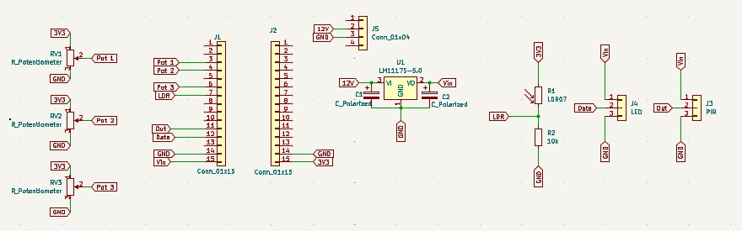
Fig.3 Screenshot from kicad

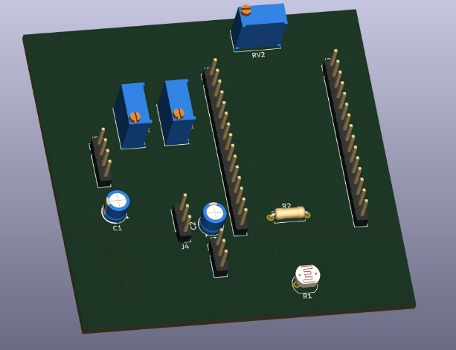
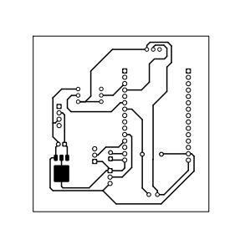

Fig.4 Pcb layout Fig.5 3d view of pcb layout

The images show the complete design flow of the intelligent lighting system using the ESP32 microcontroller. The first image is the circuit schematic including potentiometers, LDR, PIR sensor, LED output, and voltage regulator connections. The second image represents the PCB track layout with copper traces for electrical connections. The second image represents the PCB track layout with copper traces for electrical connections. The third image is a 3D PCB view showing component placement and overall physical design of the circuit.

4.5 Final project photograph and working

The final working of The Motion-Based Smart LED Lighting System is a seamless integration of environmental sensing and a programmed state machine. The system operates by continuously evaluating the physical world through its sensors and adjusting the LED output via high-speed Pulse Width Modulation (PWM).
4.5.1 The Power-On and Initialization Phase
When the system is powered via the 5V DC supply, the ESP32 initializes its GPIO pins and establishes the PWM frequency (typically 5kHz for flicker-free light). During the first few seconds, the PIR sensor undergoes a stabilization period. Simultaneously, the ESP32 samples the three potentiometers to define the duration of T1, T2, and T3, and the Lux potentiometer to set the "Darkness Threshold."
4.5.2 The Standby and Gating Logic
In its idle state, the system stays in a low-power monitoring loop. It performs a Dual-Condition Check:
- Condition A (LDR): Is the ambient light lower than the user-defined threshold?
- Condition B (PIR): Is there a "High" signal indicating movement?
If it is daylight, the system remains "Gated," meaning it will ignore all motion to prevent energy waste. The light only triggers when the room is both dark and occupied.
4.5.3 The Three-Stage Execution (Working Sequence)
Once both conditions are met, the system enters the active sequence:
- Stage 1 (Peak): The LED instantly turns on at 100% brightness. It stays at this level for the duration of T1.
- Stage 2 (Warning): Once T1 expires, the PWM duty cycle drops to 50%. This serves as a "soft-off" warning to the occupant that the timer is running out.
- Stage 3 (Safety): If no motion is detected during T2, the light drops to a 20% safety glow. This ensures the user is never left in total darkness while navigating.
Dynamic Re-triggering and Completion
The most critical aspect of the working system is its responsiveness. If the PIR sensor detects even a slight movement during Stage 2 or Stage 3, the ESP32 interrupts the countdown and immediately jumps back to Stage 1 (100% brightness). This creates a fluid experience where the light "follows" the user's presence. If the entire sequence (T1 + T2 + T3) completes without any further motion, the ESP32 sets the PWM duty cycle to 0%, turning the LED off until the next trigger.
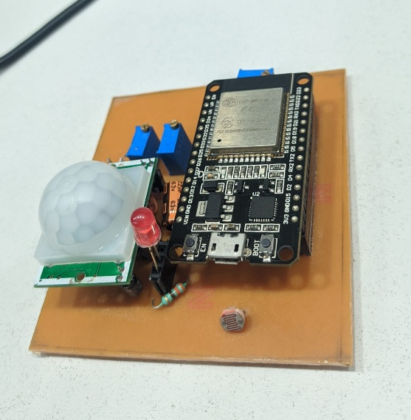

Fig.6 Photo of pcb

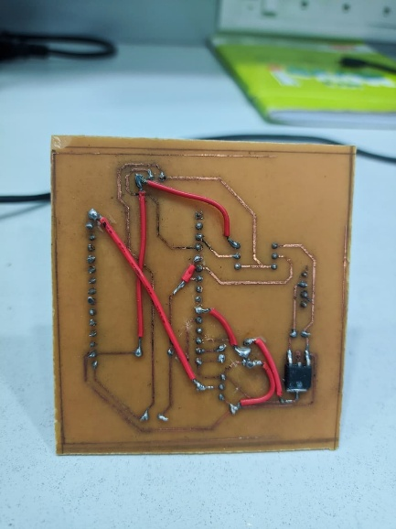 Fig.7 connection on pcb

The fig 6 and 7 shows the top view of the implemented intelligent lighting system. The main controller used is the ESP32 microcontroller mounted on a general-purpose PCB. A Passive Infrared (PIR) sensor with a white dome is placed to detect human motion. An LDR (Light Dependent Resistor) is positioned at the front to sense ambient light intensity. A red LED is used as the output indicator representing the lighting system. The components are interconnected using resistors and wiring, forming a compact prototype setup. Displays the bottom view of the PCB, showing the soldered connections and circuit layout. Copper tracks and solder joints are used to establish electrical connections between components. Red jumper wires are utilized for routing signals across different sections of the board. The layout reflects a manually designed and assembled circuit, ensuring proper connectivity and functionality of the system.

CHAPTER 5: Results and Discussion

Conclusion

This project presents an intelligent, energy-efficient lighting system using the ESP32 microcontroller with PIR and LDR sensors for smart decision-making. By combining motion detection with ambient light sensing, the system minimizes unnecessary power consumption while maintaining user comfort.
The implementation of a three-stage dimming mechanism (T1, T2, T3) provides a smooth and safe transition of light intensity instead of abrupt switching, enhancing usability. Additionally, the inclusion of adjustable parameters through potentiometers allows the system to be customized for different environments.
Overall, the proposed system successfully demonstrates a practical, low-cost, and scalable solution for smart lighting applications, contributing to energy conservation and improved user experience

Future Scope

The future scope for The Motion-Based Smart LED Lighting System involves transitioning from a standalone hardware unit to a fully integrated, data-driven ecosystem. By leveraging the untapped capabilities of the ESP32 and emerging smart technologies, the system can be scaled for industrial and city-wide applications.
- Integration with IoT platforms for remote monitoring and control
enabling users to manage lighting through mobile apps or web dashboards.
This can improve convenience and allow real-time energy tracking.
- Implementation of wireless communication features of the ESP32 microcontroller
to connect the system with smart home ecosystems.
This allows seamless automation with other devices.
- Incorporation of machine learning algorithms for adaptive behavior
enabling the system to learn user patterns and optimize lighting automatically.
This can further enhance energy efficiency and personalization.

Addition of advanced sensors such as temperature and occupancy counters
to improve decision-making and environmental awareness.
This will make the system more intelligent and responsive.

References

- Smart Light Electricity Automation and Monitoring System Based on IoT (2024).
- An IoT-Based Smart Lighting System for Real-Time Occupancy Monitoring (2025).
- A Model of an Autonomous Smart Lighting System Using Sensors (2026).
- Automation of Room Lighting System Using Arduino and PIR Sensor.
- Automatic Lighting System in Smart Homes for Elderly Based on IoT (2024).
- IoT Based Smart Lighting System Using PIR Sensors and Arduino.
- Internet of Things (IoT) Based Home Automation Using ESP32.
- Design and Development of Smart Pedestrian Lighting System (2025).
- Comprehensive Survey on IoT-Based Smart Public Street Lighting (2024).
- Adaptive Indoor Lighting Control System Using ESP32 and IoT (2025).

